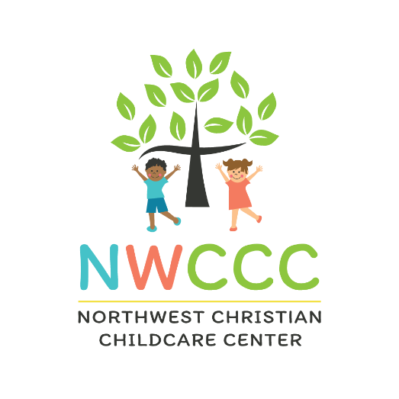

WELCOME TO AFTERCARE AT NWCCC

Northwest Christian Childcare is offering Aftercare for the 2024-25 school year. We will run bus routes from Bluffsview Elementary and Evening Street Elementary. Bluffsview Elementary children will be picked up first and returned to Northwest. The buses will then pick-up children from Evening Street Elementary. Our program is a full-time program. Once enrolled, you will be charged the monthly amount whether your child is in attendance or not. Aftercare tuition is not adjusted for holidays and vacation vouchers do not apply to Aftercare.
Date: August 14, 2024-May 22, 2025
NWCCC is closed for the following holidays:
- Teacher Workday (Aug 16)
- Labor Day
- Thanksgiving Day and the day after Thanksgiving
- Christmas Eve and Christmas Day
- New Year’s Day
- Martin Luther King Jr. Day
- Teacher Training Day (TBD)
- Good Friday
- Memorial Day
Tuition Rates: $500 per month with a yearly non-refundable registration fee of $100. Withdrawal from the Aftercare program requires a one month written notice. A one-month advance deposit ($500) is due at the time of registration, which is applied to your last month’s tuition, if at least one month’s notice has been given in written form. A late fee of $1.00 per minute will apply if your child is picked up after 6:00 pm.
Registration Info: PRIORITY REGISTRATION for current NWCCC childcare and Aftercare families begins at 10:00am on April 8 and will continue through April 12, 2023. OPEN ENROLLMENT for new families begins April 15.
To register for Aftercare, fill out the information in the Aftercare Registration box on our website (www.northwestchristianchildcare.org ) and then click Submit. Enrollment confirmations will be sent out in the weeks following registration.

We will take care of everything from the time the school bell rings at the end of the day until 6:00 pm. After returning to NWCCC, we will provide a snack, homework time, fun activities, and gym/outside playtime.

We have a limited number of spots available for each school, so REGISTER EARLY!
Anita Walker, NWCCC Director

